Year 3 Home learning w/c 30.03.20

Hi Year 3!

We hope you are having a good time at home and enjoying some of the activities we sent you.

Try to make sure you read for at least 30 minutes a day and why not keep writing in your reading records so you can tell us about all the amazing books you read when we next see you?

Also keep practising those times tables – if you can do your 2, 3,4, 5, 8 and 10 times tables, try moving on to the 6 and 7 tables!

**English – writing a playscript**

**Day 1**

Who uses a script?

In what situations would a script be needed?

Watch the video:

<https://www.bbc.co.uk/bitesize/topics/zsn4h39/articles/zx8kng8>

**Features of a playscript:**

* The setting is briefly described at the beginning of the scene.
* Character’s name in the left-hand margin shows who is speaking.
* There is a colon (:) after the character’s name
* No speech marks
* Each person’s speech starts on a new line
* Stage directions for the actors in brackets after the character’s name
* Movements by the characters, including exits and entrances, are written on separate lines, in italics, and in the present tense
* A new scene to indicate a change in time or place.

Read the playscript and see if you can find the features described above.

**A Christmas Carol**

*It was Christmas Eve in London. In the back of a cold, damp office sits the mean-spirited Ebenezer Scrooge. His partner in the business, Jacob Marley, had died seven years before. He is working in silence, counting his coins. His clerk, a kind-hearted man named Bob Cratchit, shivers in another room.*

***Scene 1***

**Bob Cratchit: Can I make a fire please Mr Scrooge?**

**Scrooge: Work faster, that will warm your hands up**

**Bob Cratchit Y-y-y-yes sir...**

*(Scrooge's nephew, Fred, enters the office.)*

**Fred: Uncle Scrooge, good day to you. Please excuse the snow on my boots**

**Scrooge: What do you want? Can’t you see I’m working?**

**Fred: I have brought a gentlemen to see you**

*(A fat gentleman with a charity collecting tin enters.)*

**Gentleman:** *(very jolly)* **Good day to you sir**

**Scrooge:** *(miserably)* **Good? What is so good about it?**

**Gentleman 1: Why it is good because it’s Christmas. A time to think of the poor and all people less well off. Will you give some money to help the poor?**

**Scrooge:** *(laughing nastily)* **Give? To the poor? They should get working. If one job does not pay enough they should stop producing children. I will NOT give money away?**

**Fred: Excuse my grumpy old uncle. Here sir I will give one gold coin from me and one on behalf of my grumpy old Uncle**

**Gentleman: Merry Christmas to you Fred and to you Mr Scrooge. I must be on my way now. Good day.**

*(The gentleman leaves. The door shuts behind him.)*

***Scene 2***

**Scrooge: Christmas! Bah Humbug!**

**Fred: Uncle Scrooge however grumpy you are remember that tomorrow, if you wish to have Christmas dinner with my family and I, you will always welcome. I must rush off now, good day Uncle and a Merry Christmas to you.**

*(Fred leaves.)*

**Scrooge: Christmas! Bah Humbug! Cratchit, what do you make of all this fuss over Christmas?**

**Bob Cratchit: Mr Scrooge, don’t be too hard on people. It is Christmas Eve. People need their fun**

**Scrooge: Fun? Humbug!**

**Bob Cratchit: Remember Mr Scrooge, peace and good will to all men. I was rather hoping that I could leave work early today?**

**Scrooge: Leave early. Why yes of course. Oh yes. Off you go now.**

**Bob Cratchit: Oh really Mr Scrooge? How very kind. Let me put on my hat and scarf, must be warm in the snow. Well off I go. So kind of you Mr Scrooge. Merry Christmas.**

**Scrooge: Before you rush off let me just make a note. Christmas Eve, remember to NOT PAY MR CRATCHIT FOR TODAY AS HE WENT HOME EARLY! THERE! Now off you go, good day to you!**

**Bob Cratchit:** *(miserably)* **Good day Mr Scrooge**

**Day 2:**

Read the myth

**The story of Arachne the Spinner**

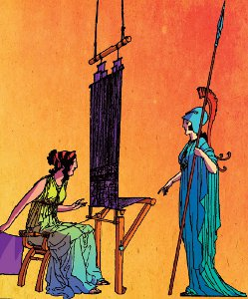

In all of Athens, no one could spin such fine thread or weave such wonderful cloth as the young woman named Arachne. People from miles around came to admire her cloth. Arachne grew so proud of her weaving that she began to boast: 'I am the most skilful weaver in the world!'  
  
'Yes, of course,' said her friends, 'next to the great goddess Athena.'  
  
'Athena? Ha!' said Arachne. 'Can she spin thread so fine, or weave it into cloth as beautiful as mine? Why, I could teach her a thing or two!'  
  
An old woman in a dark cloak spoke to Arachne. 'Be careful, my dear,' she said. 'You must show respect for the gods. Your boasting may anger Athena.'  
  
'I'm not afraid of Athena,' snapped Arachne. 'Let her come here and we'll see who is the better weaver.' Then the old woman threw back her cloak. There was a flash of light, and there stood the grey-eyed goddess, Athena. 'I am ready,' said Athena quietly. 'Take me to a loom, and let us begin. When we are finished, if your work is best, then I will weave no more. But if my work is best, then you will never weave again. Do you agree?'  
  
'I agree,' said Arachne. 'Let us begin.' She went to one loom and Athena to another. The people looked on in wonder as the goddess and the young woman wove brilliant designs into their cloth. With threads of many colours, Arachne wove cloth as fine and light as a silken web.  
  
'How beautiful!' said the people. 'It almost seems as if she could weave sunlight and rainbows into her cloth.' Arachne stepped back from her loom and turned to look at Athena's work. Into her cloth the goddess had woven flowers that seemed to bloom, and a stream that seemed to ripple by, and clouds that seemed to float peacefully in a blue sky and, above them, the dazzling figures of the immortal gods themselves. When the people looked at it, they were so filled with wonder that they gasped. Arachne herself had to admit that Athena's work was more beautiful than her own. She hid her face in her hands and wept.  
  
'Oh, how can I live if I must never spin or weave again?' she cried. When Athena saw that Arachne would never have any joy unless she could spin and weave, she said: 'I cannot break the agreement we had, but I will change you so that you spin and weave forever.' And with a touch, she turned Arachne into a spider, which ran to a corner and quickly began to spin and weave a beautiful, shining web. And that is why some people say that all spiders in the world are the children of Arachne.

1. Create a cast list. Who will be in the play?
2. Write the setting of the play to go at the beginning of your playscript.

**Day 3:**

Have a go at turning the myth of Arachne The Spinner into a playscript.

|  |  |
| --- | --- |
| **Success Criteria: Playscripts** | |
| Description of setting at the beginning of the scene |  |
| Different scenes |  |
| Characters’ names in the margin |  |
| Colon (:) after characters’ names |  |
| No speech marks |  |
| Stage directions in brackets |  |
| Adverbs (ly words) in brackets to tell characters how to say their lines |  |

**Day 4: Grammar revision**

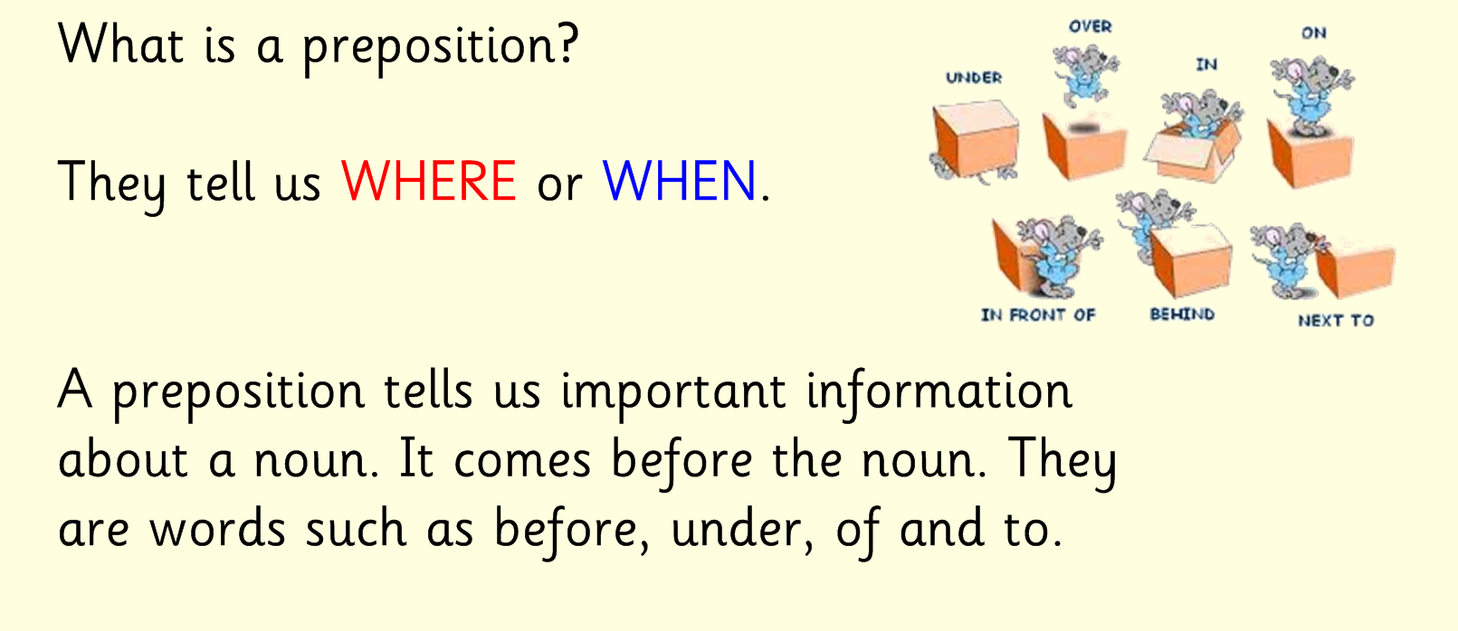

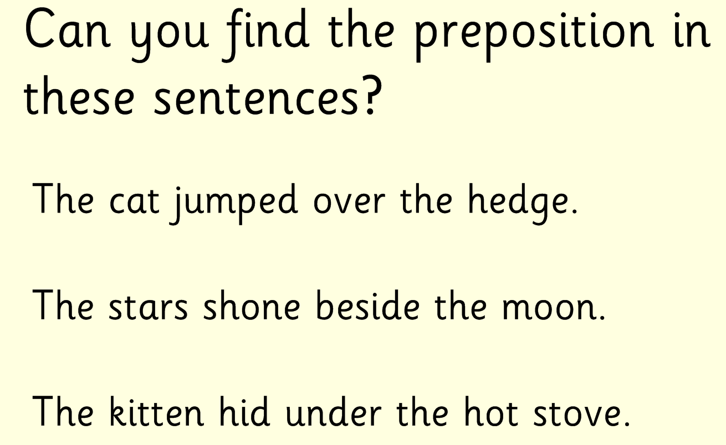

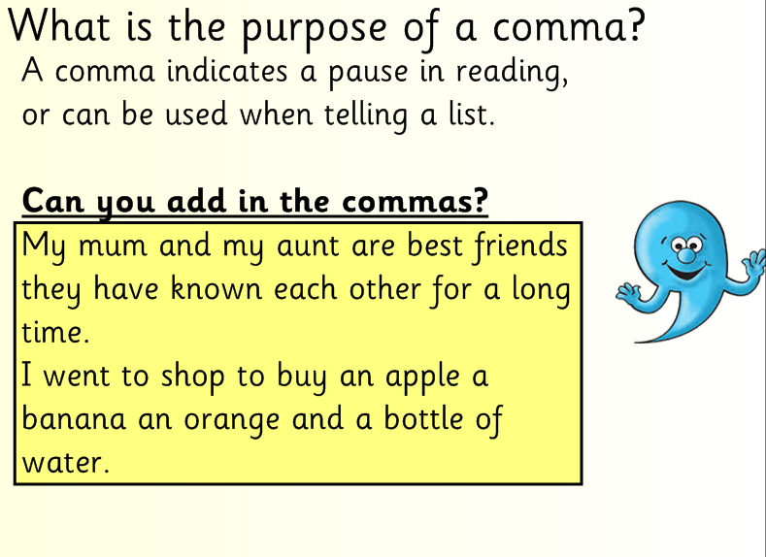

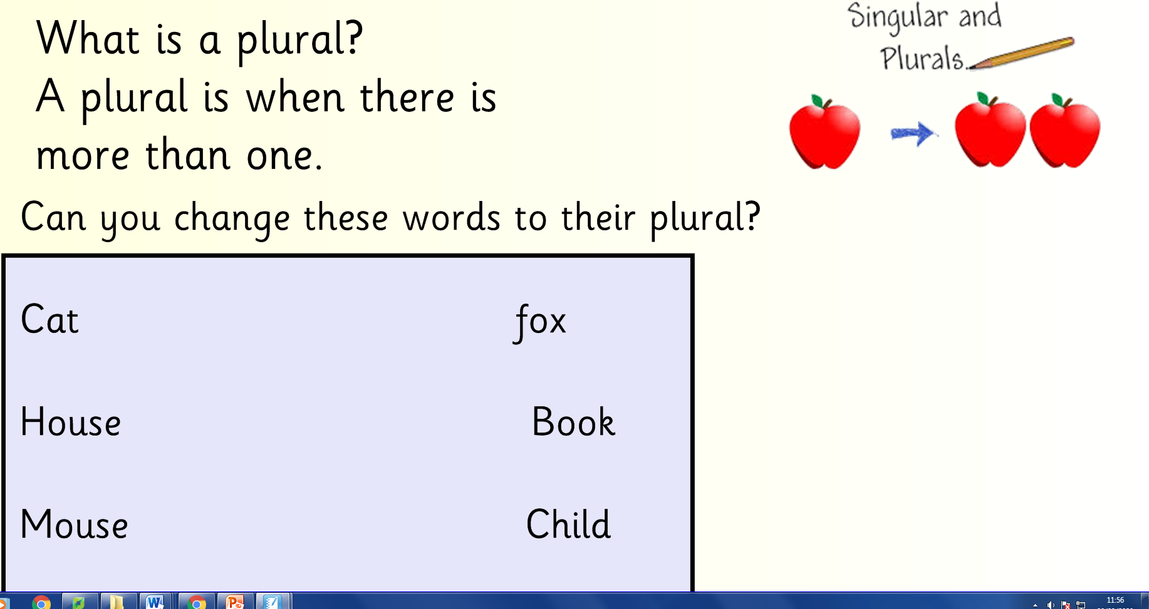

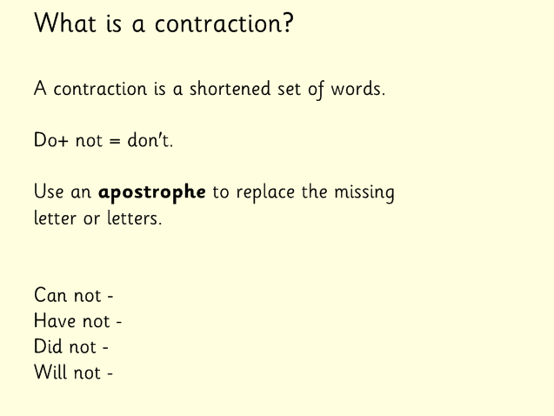

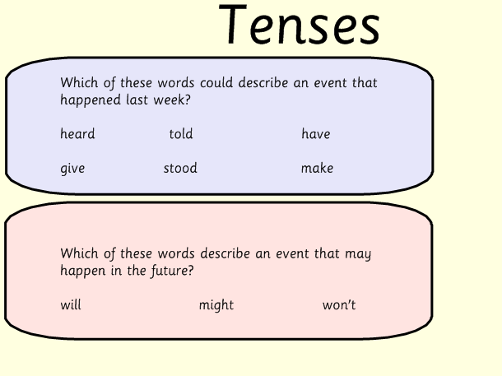

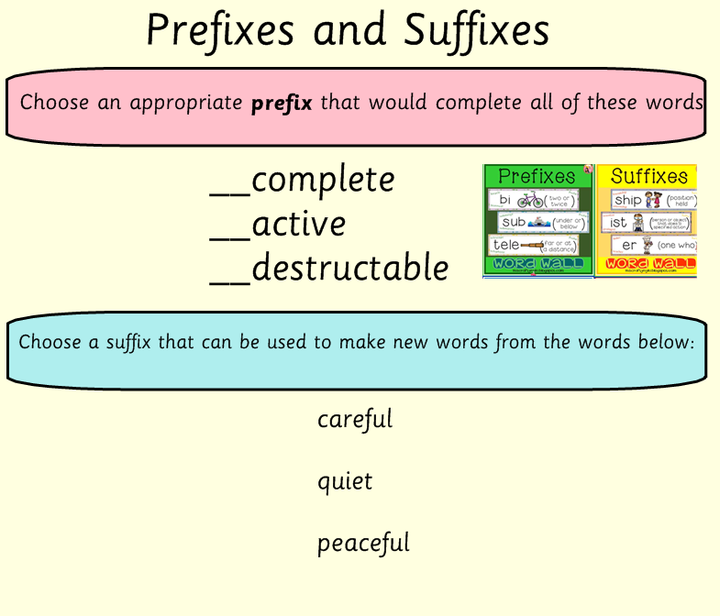

**Spelling -** Words with c sound spelt ch

Description: j0287501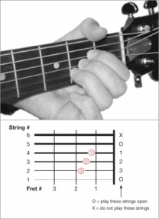a**ch**e

ar**ch**itect

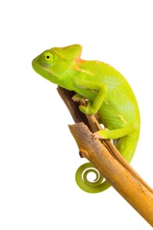an**ch**or

**ch**ameleon

**ch**aos

Description: MCj04126680000[1]**ch**aracter

**ch**emist

**ch**oir

**ch**ord

**ch**orus

**Ch**ristmas

Can you think of any others?

s**ch**ool

stoma**ch**

e**ch**

**Maths – Perimeter of 2D shapes**

**Day 1**

<https://www.bbc.co.uk/bitesize/topics/zvmxsbk/articles/zsr4k7h>

The **perimeter** is the distance all the way around the **outside** of a 2D shape.

To work out the perimeter, add up the lengths of all the sides.

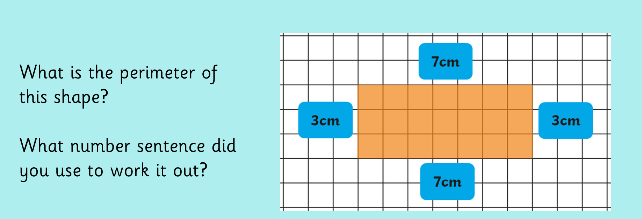

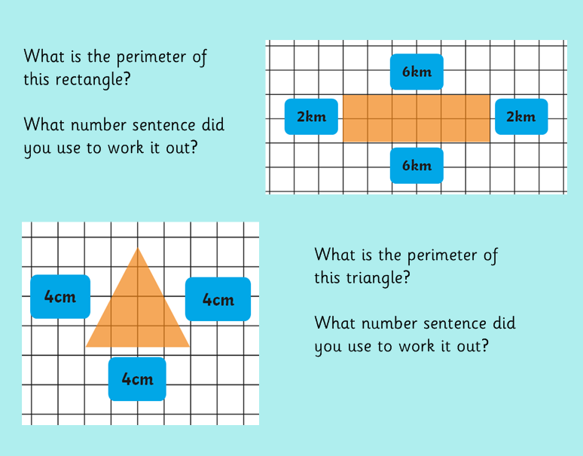

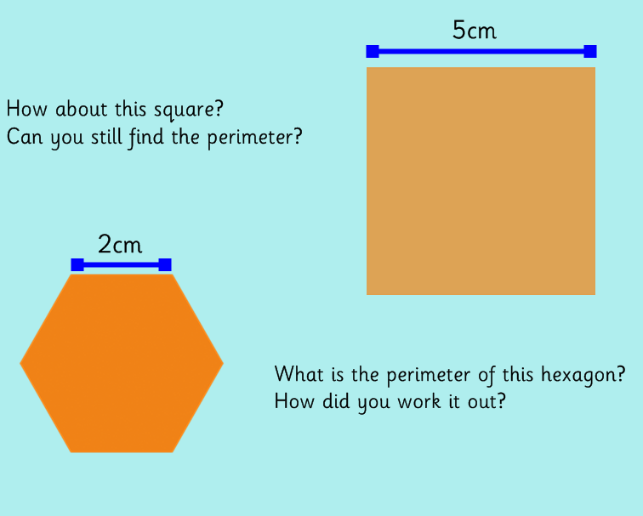

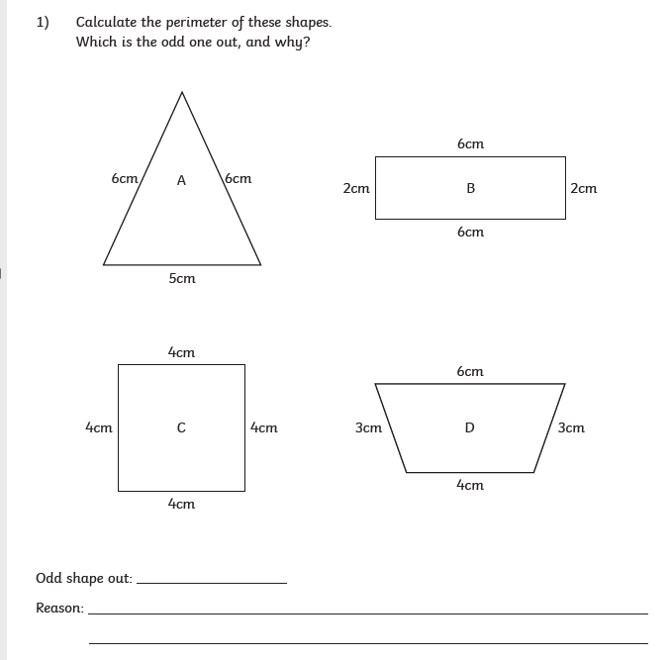

**Challenge questions: 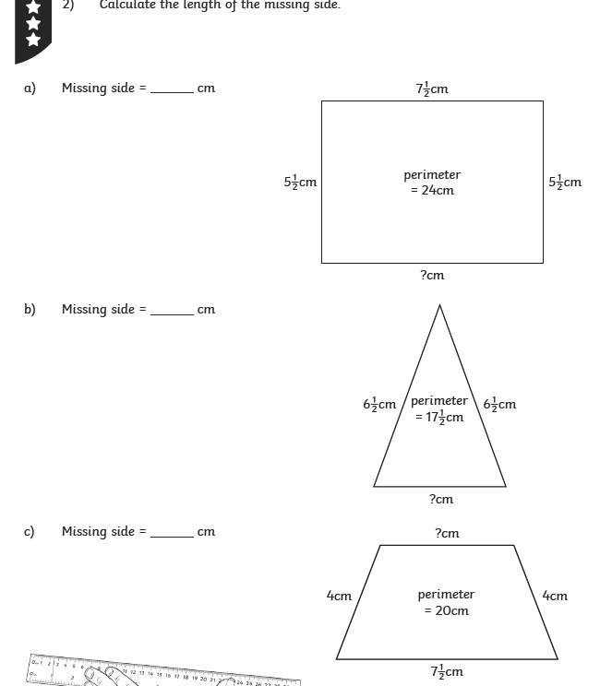Extra challenge:**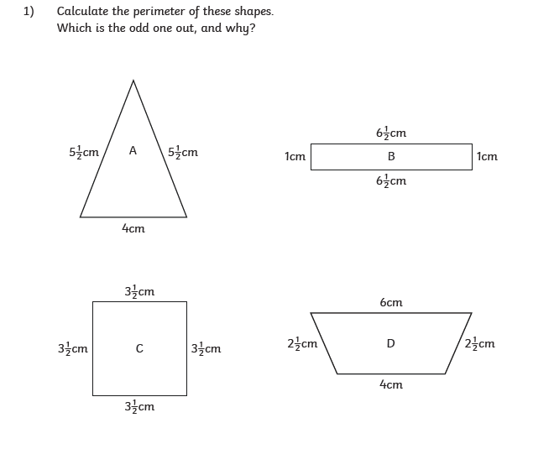

**D**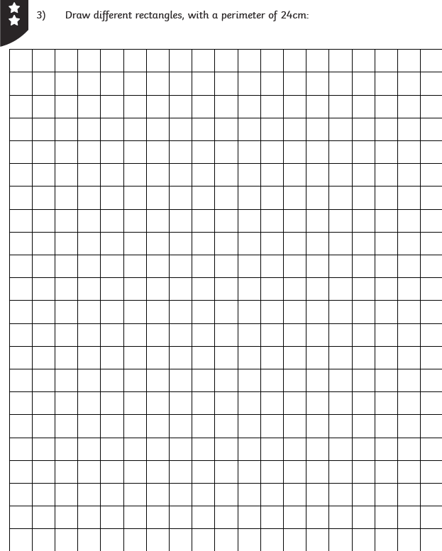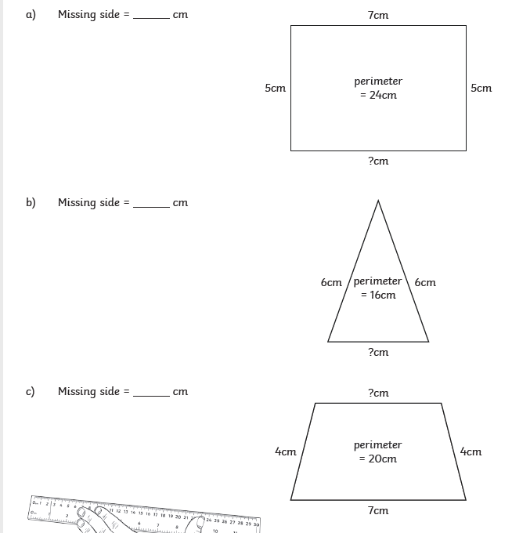

**Day 2 – perimeter problems**

**Warm up**

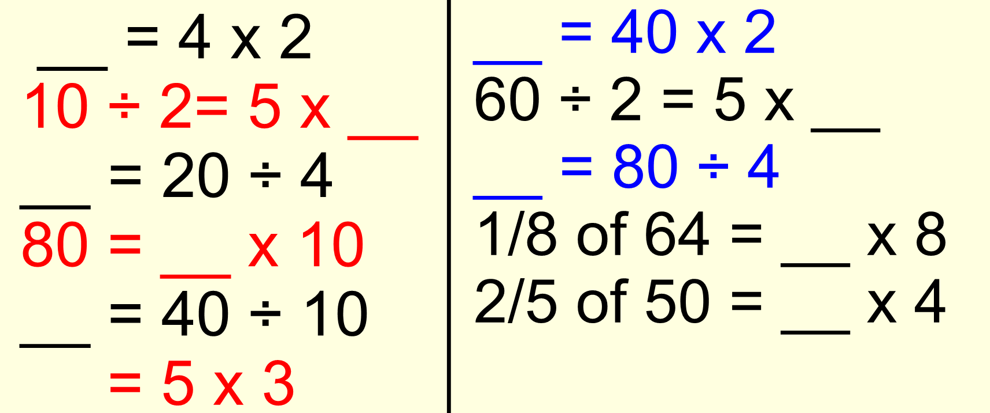

**Draw these following shapes using a ruler. Choose which option (hard/harder/hardest)**

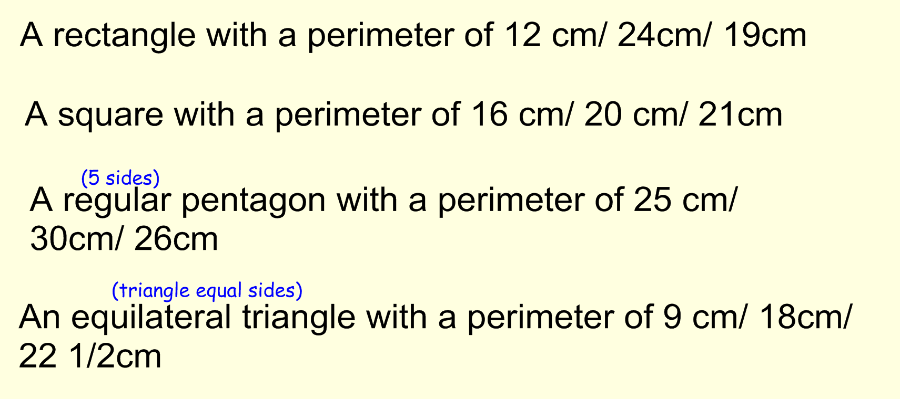

**Day 3** 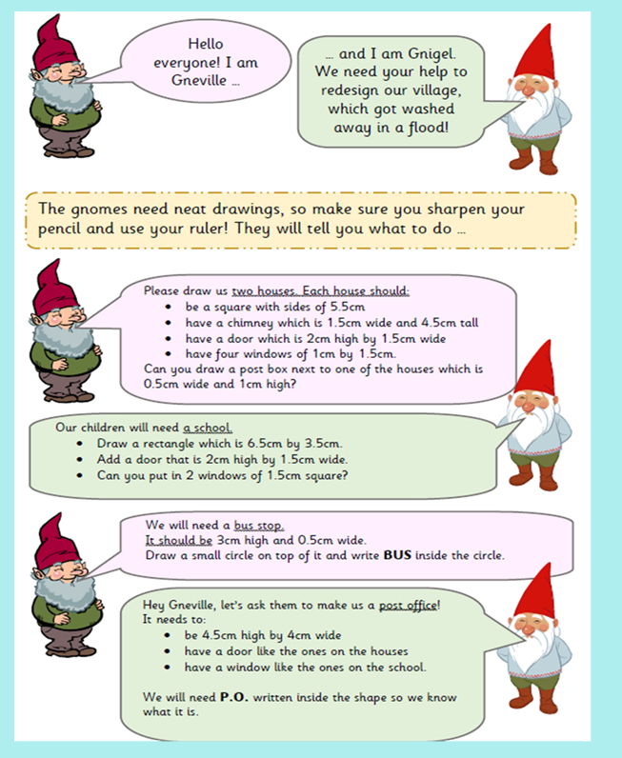

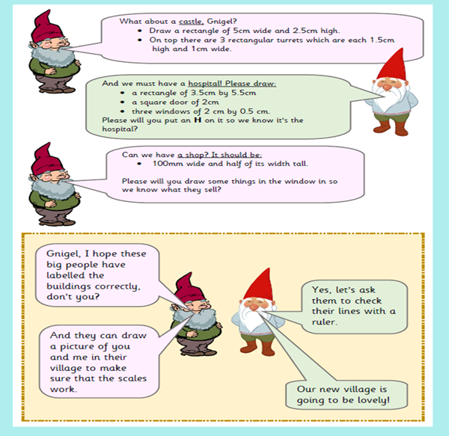

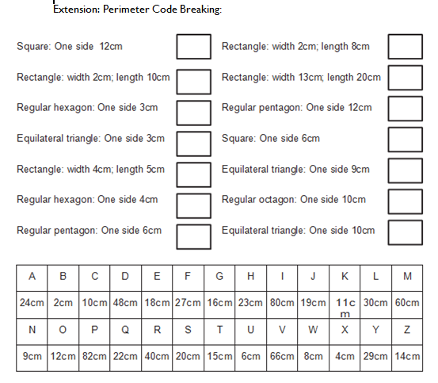

**Day 4 Times-tables**

<https://www.bbc.co.uk/teach/supermovers/ks1-maths-the-4-times-table-with-cyril-the-swan/zmsw382>

<https://www.bbc.co.uk/teach/supermovers/ks2-maths-the-8-times-table-with-filbert-fox/z4mrhbk>

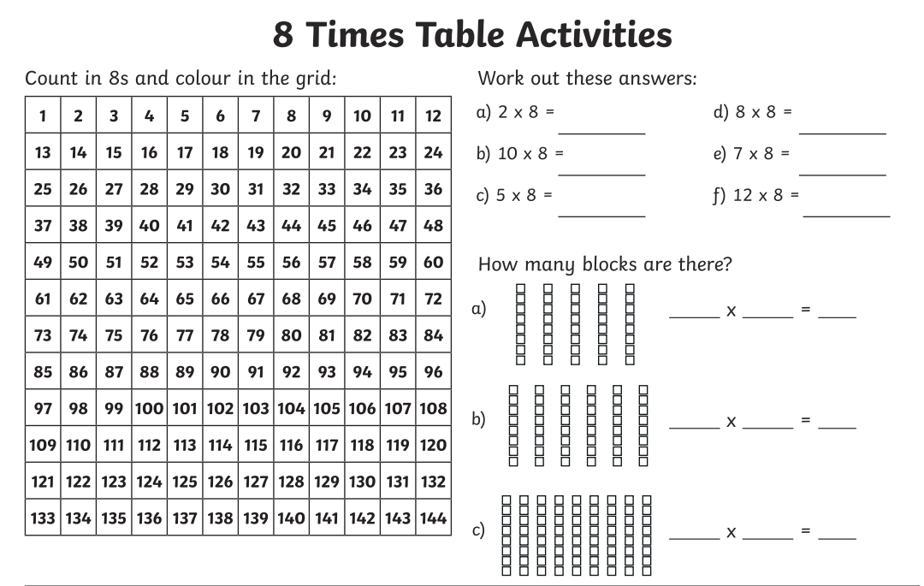

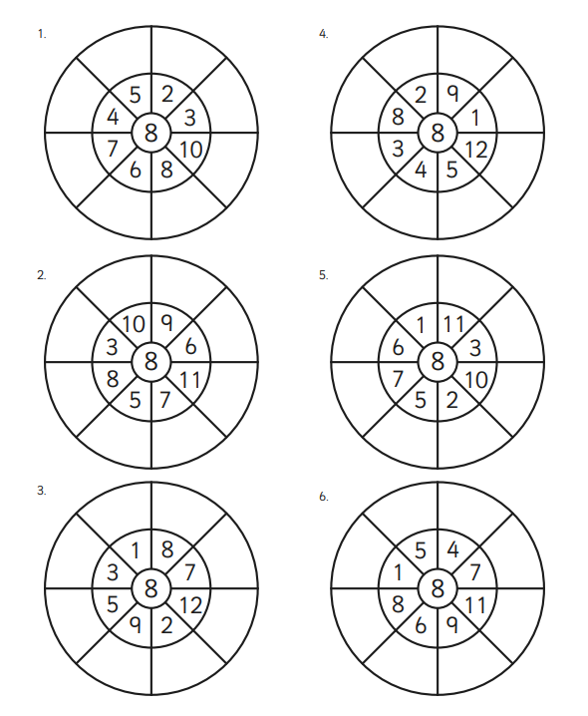

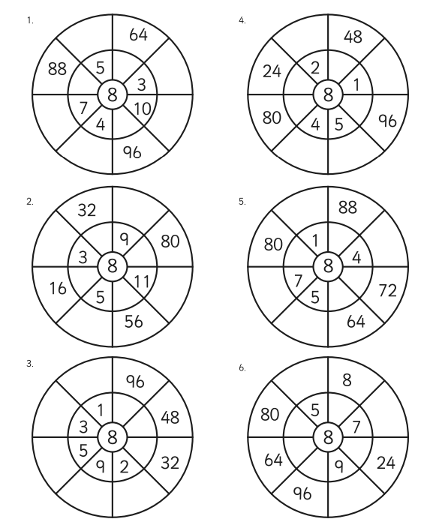

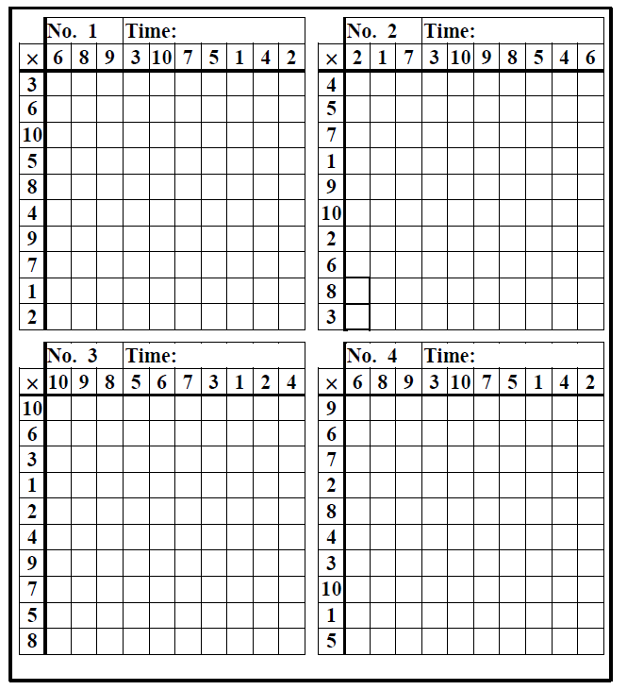

**History**

**Go through the Powerpoint and learn about the Trojan War and the Trojan Horse.**

**See attached link for PowerPoint**

You are going to pretend to be a journalist in Athens and write a newspaper article about the Trojan Horse trick.

What should each section of your newspaper article include?

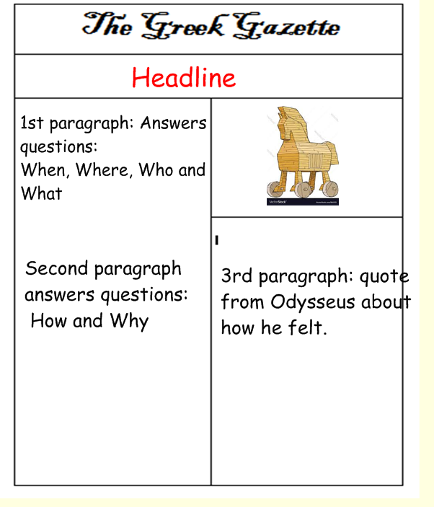

**Information to include in your article.**

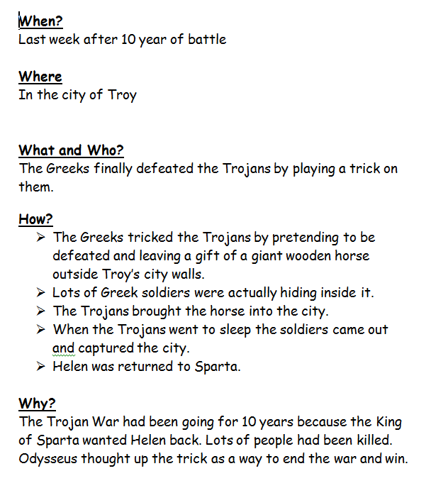

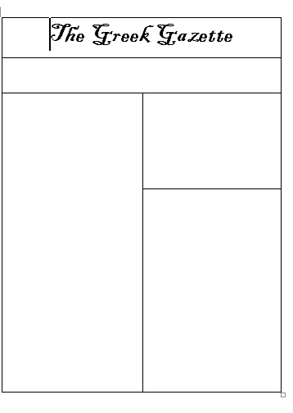

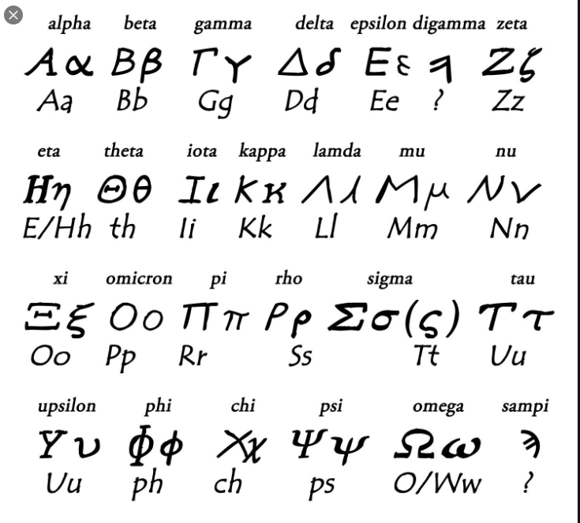**Challenge activities:**

The Greeks used a different alphabet to ours. Have a look at the symbols and names they used for each letter or sound.

Challenge 1: Find the Greek letter which your name starts with (or a letter in your name) and draw it out on an A4 piece of paper. Decorate using patterns, colours and pictures that represent you!

Challenge 2: Design your own alphabet. Think of a symbol for each letter. Can you use your new alphabet to write a message?

Maybe share your alphabet virtually with a friend and then you can use it to write each other messages in code!