Kerry’s Counting and number recognition game
You will need:

-Lolly sticks or straws
-Wrapping paper
-Card or foam squares
-Numbers written out on circles 1-10 or -number stickers
-Small plant pots or yoghurt pots
-Glue or sticky pads
-Sticky gems to decorate
Design your flower on a piece of foam , card or wrapping paper.
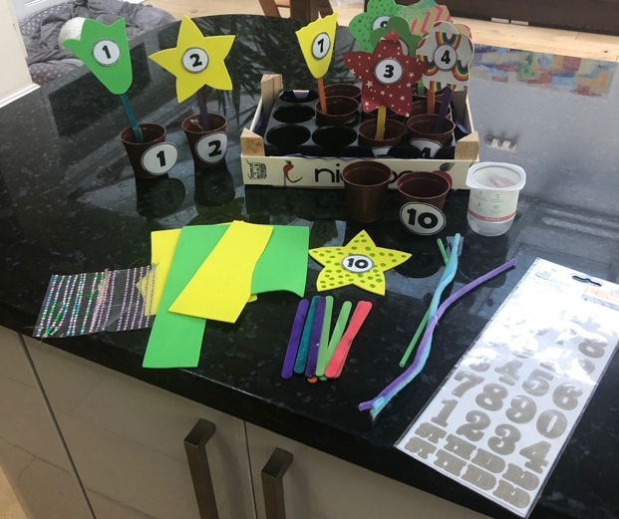

Cut the shape and place your number circle or sticker in the middle. Attach your lolly stick or straw to the back.
Now stick your flower to your pot.

Search around your home looking for items to count
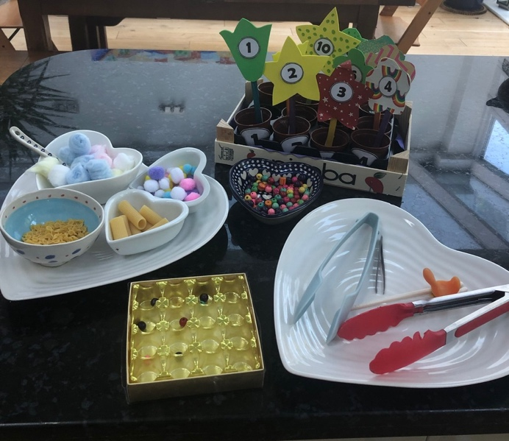
Here are some ideas.
-pom poms
-cotton wool balls
-pasta
-pebbles
-beads
-cheerios
-bottle lids

now you will need some tools to transfer your counting items
you can use
twezers
kitchen tongs
spoons
cheats chopsticks
Have fun looking at ways to transfer your counters.
.

